How to Access the Hub
You can get to the Hub two ways:

Long way but foolproof
- Go to www.houstonisd.org
- Scroll down till you see the Powerup Hub icon and click it.
- Click on the box that says “Login using Houston ISD account”
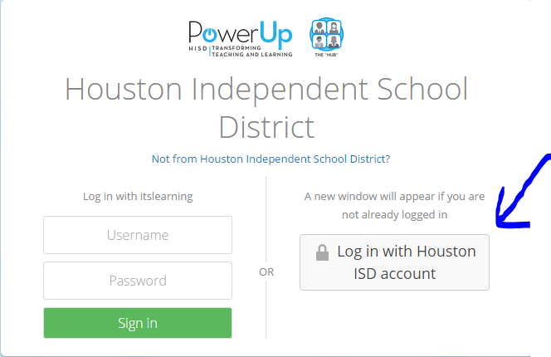
- Enter your login information:
Username: student ID preceded by the letter “S” (e.g.: S123456)
Password: birthdate as 8 digits in mmddyyyy format (e.g: 01012007)
Short way
- Go to https:\\houston.itslearning.com
- Click on the box that says “Login using Houston ISD account”
- Enter your login information:
Username: student ID preceded by the letter “S” (e.g.: S123456)
Password: birthdate as 8 digits in mmddyyyy format (e.g: 01012007)

